Lab 09: FOCP Do While Loops

# Name: Hassan Shahzad

# Class: BSCS 7C

# CMS ID: 211798

## Task 01:

#define _CRT_SECURE_NO_WARNINGS

#include <stdio.h>

#include <stdlib.h>

int main( )

{

char guestName1[] = "HAMZA";

char guestName2[] = "ILSA";

int totalNights;

int nightsSpent;

double totalCost;

printf( "How many nights do you plan to stay? " );

scanf( "%d", &totalNights );

printf( "\nTotal planned stay: %d nights.\n", totalNights );

printf( "%s travels to Chitral....\n\n", guestName1 );

nightsSpent = 0;

totalCost = 0.0;

while ( nightsSpent < totalNights )

{

printf( "%s spends a night.\n", guestName1 );

nightsSpent++;

totalCost += 1500.0;

printf( "\tNights spent: %d\n", nightsSpent );

printf( "\tNights left: %d\n", totalNights - nightsSpent );

}

printf( "\nTotal cost of stay: Rs. %.2f\n", totalCost );

printf( "\nTotal planned stay: %d nights.\n", totalNights );

printf( "%s travels to Chitral....\n\n", guestName2 );

nightsSpent = 0;

totalCost = 0.0;

do

{

printf( "%s spends a night.\n", guestName2 );

nightsSpent++;

totalCost += 1500.0;

printf( "\tNights spent: %d\n", nightsSpent );

printf( "\tNights left: %d\n", totalNights - nightsSpent );

}

while ( nightsSpent < totalNights );

printf( "\nTotal cost of stay: Rs. %.2f\n", totalCost );

return EXIT_SUCCESS;

}

//------------------------------------------------------------------------------------------------------------------------------------

// Q1) Yes, Hamza and Ilsa spend same number of nights.

// Q2) When we enter 0 nights then Hamza and Ilsa donot spend the same number of nights as Ilsa spend an extra night.

// Q3) No, Hamza just travels for Chitral and doesnot check the vacations.

// Q4) No, Ilsa also just travels for Chitral and doesnot check the vacations.

// Q4) The do while loop executes the program once before checking the condition whereas While loop checks for the condition first.

// Q5) Do while loop is post-test loop whereas while is a pre-test loop.

//------------------------------------------------------------------------------------------------------------------------------------

## Task 02:

#define _CRT_SECURE_NO_WARNINGS

#include <stdio.h>

#include <stdlib.h>

#include <string.h>

#include <time.h>

int FlipCoin() {

int result = 1 + rand() % 2;

return result == 1;

}

int main()

{

// initialize random seed

srand(time(NULL));

char again = 'y';

char coin[] = "";

do

{

int flip = FlipCoin();

if ( flip == 1 )

strcpy( coin, "HEADS" );

else

strcpy( coin, "TAILS" );

printf( "You flip a coin and it is... %s\n", coin );

printf( "Would you like to flip again (y/n)? " );

scanf( " %c", &again );

} while (again == 'y');

return EXIT_SUCCESS;

}

// If we donot initialize the variable again then it checks the condition after executing the program and program runs smoothly.

## Task 03:

#define _CRT_SECURE_NO_WARNINGS

#include <stdio.h>

int main()

{

// random number from 1 to 6

srand(time(NULL));

int total = 0;

printf("HERE COMES THE DICE! \n\n"); // displaying HERE COMES THE DICE

int RandDice1 = 1 + rand() % 6; // declaring variables

int RandDice2 = 1 + rand() % 6;

do

{

RandDice1 = 1 + rand() % 6; // declaring variables

RandDice2 = 1 + rand() % 6;

printf("Roll #1: %d\n", RandDice1); // displaying roll #1

printf("Roll #2: %d\n", RandDice2); // displaying roll #2

total = RandDice1 + RandDice2; // assigning value to total

printf("The total is = %d\n\n", total);

}

while (RandDice1 != RandDice2);

}

## Output:

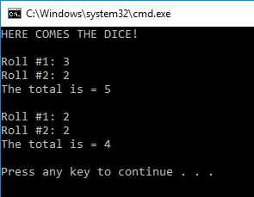

## Task 04:

#define _CRT_SECURE_NO_WARNINGS

#include <stdio.h>

int main()

{

int secret = 6; // declaring secret

int guess; // declaring guess

printf(" I have chosen a number between 1 and 10. Try to guess it. "); // asking user to input a number

scanf("%d", &guess);

printf("Your guess: %d\n", guess); // tells the user about his guess

do

{

printf(" That is incorrect. Guess again. \n"); // tells the user that he has entered a wrong value

printf(" I have chosen a number between 1 and 10. Try to guess it. "); // again asks the user to enter a value

scanf("%d", &guess);

printf("Your guess: %d\n", guess);

}

while (secret = guess);

printf("That's right! You guessed it.\n"); // tells the user that he has entered correct value

}

## Output:

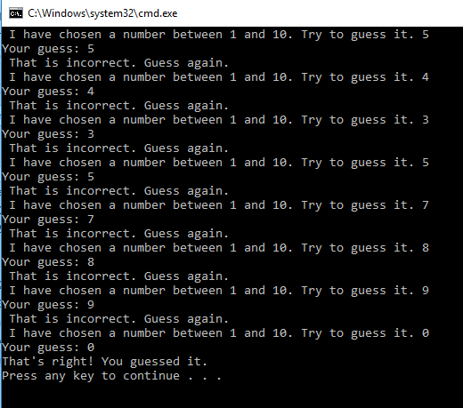

## Task 05:

#define _CRT_SECURE_NO_WARNINGS

#include <stdio.h>

#include <math.h>

int main()

{

double square_root;

int a;

printf("SQUARE ROOT!\n");

do

{

printf("Enter a number : ");

scanf("%d", &a);

if (a < 0)

{

printf("\nYou can't take the square root of a negative number.");

printf("\nTry Again : %d\n", a);

}

if (a>0)

{

square_root = sqrt(a);

printf("\nThe square root of %d is %lf\n", a, square_root);

}

} while (1);

}

## Output:

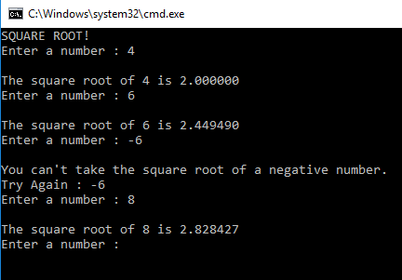

## Task 06:

#define _CRT_SECURE_NO_WARNINGS

#include <stdio.h>

#include <math.h>

int main()

{

int a, b, c;

while(1)

{

printf("Enter three integers: \n");

printf("Side 1: ");

scanf("%d", &a);

printf("Side 2: ");

scanf("%d", &b);

while (b < a)

{

printf("%d is smaller than %d TRY AGAIN\n", b, a);

printf("Side 2: ");

scanf("%d", &b);

}

printf("Side 3: ");

scanf("%d", &c);

printf("\n\n");

printf("Your three sides are %d %d %d\n", a,b,c);

if (a*a + b*b != c*c)

{

printf("NO! These sides do not make a right triangle!\n");

}

else {

printf("These sides *do* make a right triangle.\n");

}

if (a*a + b*b == c*c)

{

return 0;

}

}

return 0;

}

## Output:

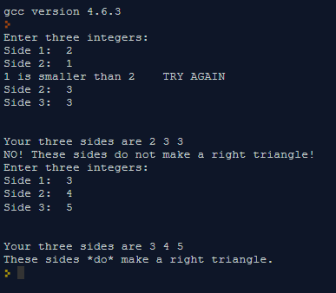

## Task 07:

int main()

{

int n;

printf("\nstarting number:");

scanf("%d",&n);

do{

if (n%2==0){

n=n/2;

printf("\t%d",n);

}

else{ //executes the block of code if n is odd

n=3*n+1;

printf("\t%d",n);

}

}while(n!=1);//executes the loop until the value of n reduces to 1

}

## Output:

